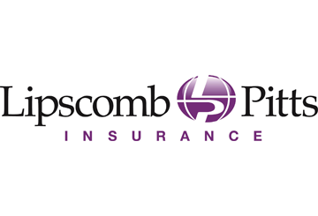
States Relax Unemployment Benefit Eligibility for Coronavirus
Action Steps
- Employers should review the DOL’s guidance and their state’s UI benefit guidance.
- Employers should consider informing their employees of federal and state benefits that may be available to them if they are prevented from working.
- Employers should continue to monitor developments related to COVID-19 for UI and other benefits.
As of Wednesday, March 18, 2020, several states have announced adjustments to their unemployment insurance (UI) programs for employees who are out of work because of the COVID-19 outbreak. These states include Alabama, California, Louisiana, North Carolina, Pennsylvania and Wisconsin. Additional states are expected to issue similar guidance in the near future.
Each state administers a separate UI program, but all states follow the same guidelines established by federal law.
Federal Bill
The U.S. Congress has passed a bill that would encourage states to waive limitations on UI benefits (such as waiting weeks and work-search requirements) for COVID-19-related claims. If enacted, the Families First Coronavirus Response Act would also provide federal funds to help states pay for increased UI claims caused by the outbreak.
DOL Guidance
The ongoing wave of state adjustments to their UI benefits follows new guidance from the U.S. Department of Labor (DOL). On March 12, 2020, the DOL indicated that states may allow for UI benefits where:
- An employer temporarily ceases operations to prevent employees from coming to work due to COVID-19;
States may allow employees to receive UI benefits for closures, quarantines and unpaid leaves related to COVID-19.
- An individual is quarantined with the expectation of returning to work after the quarantine is over; and
- An individual leaves employment due to a risk of exposure or infection, or to care for a family member affected by COVID-19.
The DOL has also clarified that an employee is not required to quit in order to receive benefits due to COVID-19.
Provided to you by Lipscomb & Pitts Insurance, LLC

