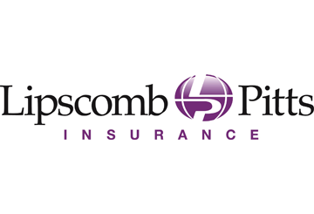
Health Plans Must Provide Free Coronavirus (COVID-19) Testing
Key Points
- Employer-sponsored group health plans must cover COVID-19 testing, without imposing a deductible, copayment or other cost sharing.
- This mandate applies to fully insured group health plans and self-insured group health plans, regardless of size.
- HDHPs can provide first dollar coverage for COVID-19 testing and remain HSA-compatible.
On March 18, 2020, President Trump signed the second coronavirus relief measure into law – the Families First Coronavirus Response Act (Act). Effective immediately, the Act requires group health plans and health insurance issuers to cover COVID-19 testing without imposing any cost sharing (such as deductibles, copayments or coinsurance) or prior authorization or other medical management requirements.
Coverage Mandate
This coverage mandate applies to the following health plans and issuers, regardless of grandfathered status under the Affordable Care Act (ACA):
- All fully insured group health plans
- All self-insured group health plans
- Health insurance issuers offering group or individual coverage
During this public health emergency, health plans and issuers must cover FDA-approved diagnostic testing products for COVID-19, including any items or services provided during a visit to a provider (in-person or telehealth), urgent care center or emergency room that relate to COVID-19 testing. This coverage cannot be subject to any plan deductible, copayment or coinsurance.
This coverage mandate does NOT require health plans and issuers to cover COVID-19 treatment at no charge. Exact coverage details for COVID-19 treatment, including any cost-sharing amounts, will vary by plan.
Guidance for HDHPs
The IRS has advised that high deductible health plans (HDHPs) can pay for COVID-19 testing and treatment before plan deductibles have been met without jeopardizing their status. According to the IRS, individuals who are participating in these plans may continue to contribute to their HSAs.
Effective immediately, health plans and health insurance issuers must cover COVID-19 testing at no charge.
Provided to you by Lipscomb & Pitts Insurance, LLC

