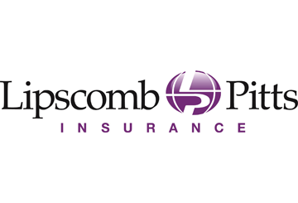

Returning to Work Post-COVID-19
Provided by: Lipscomb & Pitts Insurance, LLC

Table of Contents
Introduction 5
Return-to-Work Plans: An Overview 6
Return-to-Work Plans: Introduction 6
COVID-19 Return-to-Work Plans at a Glance 6
Return-to-Work Considerations 8
Reopening Decisions and Risk Assessments 10
Determining When to Reopen 10
Conducting a Risk Assessment 10
Maintaining Workplace Safety Using OSHA and CDC Guidance 12
Creating a Pandemic Response Team 14
Modifying the Workplace 16
Employee Telecommuting Considerations 17
Effectively Leading Remote Teams 18
Challenges of Leading Remote Teams 18
How to Effectively Lead Remote Teams 18
Providing Support for Remote Employees 19
Productivity Among Remote Teams 19
Disinfecting the Workplace 20
Establishing Employee Screening, Exposure and Confirmed Illness Protocols 21
Employee Screening Protocols 21
Best Practices for Implementing Temperature Testing 22
Contact Tracing in the Workplace 23
Exposure and Confirmed Illness Protocol 25
Creating Employee Safety Training Materials 26
Social Distancing Guidelines 26
Use of PPE 26
Cleaning Responsibilities 27
Industry- and Business-specific Safety Considerations 27
Reviewing Workplace Policies 28
Reopening a Business 29
Managing a Post-COVID-19 Reputation. 30
Why Is Your Reputation Important? 30
How Can Your Reputation Be Affected? 30
Best Practices 31
Be Prepared 32
Appendix 33
Sample Return-to-Work Action Plan 34
5 Practice and Policy Considerations in Advance of Return to Work – Poster 42
Post-coronavirus Workplace Preparedness Checklist 43
Responding to a Positive COVID-19 Test Checklist 46
COVID-19 Scenarios and Benefits Available Chart 49
Remote Work Policy 50
Sample Return-to-Work Employee Communications Email 53
Remote Work Agreement Form 54
Updating the Office Poster 56

Introduction
The coronavirus (COVID-19) pandemic has fundamentally changed the world in only a few short months. COVID-19 has jeopardized the health of individuals and businesses alike, and the lingering effects aren’t going anywhere. Additionally, despite states reopening after weeks of shelter-in-place orders and relaxing some restrictions, the coronavirus hasn’t slowed. More to the point, employers must contend with this reality and begin reimagining what their organizations will look like after reopening—it will not be “business as usual” for a very long time, if ever again.
This isn’t an alarmist perspective—it’s pragmatic. Experts predict a resurgence of COVID-19 cases in the fall, much like the common flu. In other words, employers must plan for ways to limit the spread of the coronavirus right now or risk interrupted business operations in the near future.
Now is the time for employers to reshape their workplaces for the betterment of employees and their businesses altogether. This toolkit includes a variety of expert guidance aimed at helping employers design and implement a return-to-work program. It features an appendix full of printable resources to help employers get a jump-start.
As always, please contact Lipscomb & Pitts Insurance, LLC for more information or to request additional resources. Through us, you have access to countless presentations, videos, educational materials, posters, HR forms and much more. Contact us to learn more.

Return-to-Work Plans: An Overview
The coronavirus pandemic has interrupted many businesses across the country. While it’s unclear how long COVID-19 will continue to affect organizations, many employers are looking to the future of employees returning to work.
A return to normalcy won’t be like flipping a switch, but rather a gradual effort. In preparation for reopening their businesses and asking employees to come back to work, it’s imperative that employers thoughtfully construct a return-to-work plan for their employees to keep everyone healthy and safe following the COVID-19 pandemic.
This section talks generally about return-to-work plans. Later sections go into more detail about the points discussed here.

Return-to-Work Plans: Introduction
A return-to-work plan is typically created to help reintegrate workers who have been injured or have been on leave. The plan includes details on how the worker will gradually return to work and any job-related specifics. Its purpose is to formalize steps for a safe and quick return to work.
There are many benefits of return-to-work plans for both the employer and the employee. Employers can enjoy increased employee engagement, proactive cost containment, reduced turnover, increased communication and improved morale with an established return-to-work plan. And it’s been proven that employees who go through return-to-work plans are able to get back to work quicker than those who don’t, meaning that employers will see increased productivity following an employee’s return to work.
Employees also benefit from return-to-work plans, as they feel supported by their employer, which increases their engagement and loyalty to the company. Going through a return-to-work plan also helps them get back to work faster and increases the likelihood that they feel secure and stable in their role.
The benefits of return-to-work plans are undeniable. While these plans are typically customized on an individual basis, an employer can use the basics of a return-to-work plan to build their approach to asking employees to return to work following the COVID-19 pandemic.

COVID-19 Return-to-Work Plans at a Glance
COVID-19 has caused many businesses to shut down or transition their employees to work from home, disrupting daily work life for many. As stay-at-home regulations are scaled back and all businesses are allowed to resume as normal, employees will be asked to come back to work. While they may not be coming back from an injury or leave, employers need to have a plan in place for all employees to safely and successfully return to work.
While employers may need to tailor their organization’s COVID-19 return-to-work plan to employees’ specific needs (e.g., child care arrangements, caregiving responsibilities and health issues), having a generalized plan in place can help them safely reopen their business.
A COVID-19 return-to-work plan should include the following:
- Anticipated return-to-work date—With the uncertainty that COVID-19 has brought, it’s important to give clear information and dates when employees are to return to work whenever possible. Be sure to be flexible with dates, though, as local and state orders are frequently updated.
- Disinfecting and cleaning measures—Because COVID-19 can remain on surfaces long after they’ve been touched, it’s important that businesses frequently clean and disinfect the facility. Some best practices include:
  - Cleaning and disinfecting all frequently touched surfaces in the workplace, such as workstations, keyboards, telephones, handrails and doorknobs.
  - Discouraging workers from using other workers’ phones, desks, offices, or other tools and equipment, when possible. If necessary, clean and disinfect them before and after use.
  - Providing disposable wipes so that commonly used surfaces can be wiped down by employees before each use.
- Social distancing protocol—Social distancing is the practice of deliberately increasing the physical space between people to avoid spreading illness. In terms of COVID-19, social distancing best practices for businesses can include:
  - Avoiding gatherings of 10 or more people
  - Instructing workers to maintain at least 6 feet of distance from other people
  - Hosting meetings virtually when possible
  - Limiting the number of people on the job site to essential personnel only
  - Discouraging people from shaking hands
- Employee screening procedures—To keep employees safe, consider conducting screening procedures to identify potentially ill employees before they enter the office. The Equal Employment Opportunity Commission (EEOC) permits employers to measure employees’ body temperatures before allowing them to enter the worksite. Any employee screening should be implemented on a nondiscriminatory basis, and all information gleaned should be treated as confidential medical information under the Americans with Disabilities Act—specifically, the identity of workers exhibiting a fever or other COVID-19 symptoms should only be shared with members of company management with a true need to know. Be sure to notify employees of the screening process to avoid any surprises.
Employee safety training—A return-to-work plan should include detailed safety training guidance to ensure that all employees understand how they can prevent the spread of COVID-19. The plan should discuss the following safety training topics:
  - Respiratory etiquette and hand hygiene—Businesses should encourage good hygiene to prevent the spread of COVID-19. This can involve:
    - Providing tissues and no-touch disposal receptacles
    - Providing soap and water in the workplace
    - Placing hand sanitizers in multiple locations to encourage hand hygiene
    - Reminding employees to not touch their eyes, nose or mouth
  - Personal protective equipment (PPE)—PPE is equipment worn by individuals to reduce exposure to a hazard such as COVID-19. Businesses should focus on training workers on proper PPE best practices. Employees should understand how to properly put on, take off and care for PPE. Training material should be easy to understand and must be available in the appropriate language and literacy level for all workers.
  - Staying home when sick—Encourage employees to err on the side of caution if they’re not feeling well and stay home when they’re sick or are exhibiting common symptoms of COVID-19 (e.g., fever, cough or shortness of breath).
- Mental health considerations—The COVID-19 pandemic has increased stress levels of employees across the country. It’s important that an employer’s return-to-work plan includes guidance for managing employee mental health concerns when employees return to work.
- Process for individualized requests—Employees will be returning to work and facing different situations at home or with their health. An employer’s return-to-work plan should include information about how employees can go about making individualized requests for changes to a return-to-work plan. Some may have underlying health conditions that put them at greater risk of severe illness with COVID-19, meaning they may not be able to fully return to work. Others may be facing unique child care arrangements due to schools and day cares being closed. Employers should be flexible and compassionate in response to individualized requests.

Return-to-Work Considerations
Returning to work after the COVID-19 pandemic is likely to bring challenges. Some of the most common challenges that employers will need to be prepared for include the following:
- Changing worker priorities—If an organization asks its employees to work from home during the COVID-19 pandemic, employees may want to still enjoy work-from-home arrangements even after the office is reopened. Employers should be prepared for an increased demand in work-from-home requests, and may need to expand their pre-COVID-19 policies to meet this demand. In addition, prospective employees may ask about this benefit when they’re searching for a job within the company.
- Updating the office layout—Due to social distancing protocols, organizations may need to reconfigure office layouts. Employee workstations should be 6 feet apart to help prevent the spread of COVID-19.
- Adapting to changing rules and regulations—Due to the nature of the COVID-19 pandemic, rules and regulations are constantly changing. Employers should be prepared to change their business practices if needed to maintain critical operations. This could involve identifying alternative suppliers, prioritizing existing customers or suspending portions of business operations.
- Managing reputational effects—Given the scope of the COVID-19 pandemic and how much is still currently unknown about the situation, people may have strong opinions about an employer’s decision to reopen their business. They’ll need to be prepared for the reputational effects of reopening the business. By taking the steps to keep employees and customers safe and healthy, employers can manage reputational effects of opening after the pandemic.
Remember, reopening a business after the COVID-19 pandemic isn’t as simple as opening the doors. Employers will need to carefully evaluate each step of the reopening and gradually ask employees to return to work.
The following sections go into more detail about what these steps entail. Note, return-to-work processes may vary depending on the organization. Employers should be ready to adapt these best practices to suit their unique needs.

Reopening Decisions and Risk Assessments
As the coronavirus pandemic continues to affect daily life, many business owners are looking forward to the future and a return to normalcy. However, even as stay-at-home orders are being lifted and nonessential businesses are being allowed to resume operations, there’s a lot for organizations to consider before they reopen their doors. What’s more, many of these considerations are workplace-specific and could be more involved depending on the industry employers operate in.
To protect their customers and employees alike, it’s important for organizations to do their due diligence before opening their business back up to the public following the COVID-19 pandemic.

Determining When to Reopen
While many essential businesses (e.g., hospitals, pharmacies, grocery stores and gas stations) have remained open during the COVID-19 pandemic, other operations deemed nonessential have shut down temporarily or changed the nature of their operations. Not only has this led to significant business disruptions, but, for many, it has critically impacted their bottom line.
However, we may be nearing a time when stay-at-home regulations are scaled back and all businesses are allowed to resume as normal. The question then is: How will business owners know it is acceptable to reopen? The following are some best practices to keep in mind:
- Review guidance from state and local governments—The COVID-19 pandemic impacts states and regions in different ways. Just because a business is allowed to reopen in one region of the country doesn’t automatically mean operations will be allowed to resume everywhere. As such, it’s critical to understand and review all relevant state and local orders to determine if and when a business is allowed to reopen.
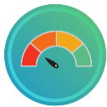
- Understand the risks—If and when the government allows all businesses to reopen, that doesn’t necessarily mean COVID-19 is no longer a threat to operations. What’s more, some businesses may have greater COVID-19 exposures than others, underscoring the importance of performing a thorough risk assessment before reopening. Prior to conducting a risk assessment, it’s important to review guidance from the Occupational Safety and Health Administration (OSHA), state and local agencies, industry associations and local health departments. More information on conducting a risk assessment can be found below.
Again, before reopening, it’s critical to seek the expertise of legal, insurance and other professionals.

Conducting a Risk Assessment
Even after the government allows businesses to reopen, firms still need to determine if it makes sense to resume operations. Safely restarting a business won’t be as simple as unlocking the front door.
Before reopening, businesses should perform a risk assessment to determine what steps must be taken. While the complexity of risk assessments will differ from business to business, they typically involve the following steps:
- Identifying the hazards—When it comes to COVID-19, businesses need to think critically about their exposures, particularly if an infected person entered their facilities. When identifying hazards, it’s a good idea to perform a walk-through of the premises and consider high-risk areas (e.g., break rooms and other areas where people may congregate). It’s also important to consider what tasks employees are performing and whether or not they are especially exposed to COVID-19 risks when performing their duties.
- Deciding who may be harmed and how—Once hazards have been identified, employers need to determine what workforce populations are exposed to COVID-19 risks. When performing this evaluation, employers will need to make note of high-risk individuals (e.g., staff members who meet with customers or individuals with preexisting medical conditions).
- Assessing risks—Next, employers must analyze them to determine their potential consequences. For each risk facing a business, employers will want to determine:
  - How likely is this particular risk to occur?
  - What are the ramifications should this risk occur?
When analyzing the risks, employers should consider potential financial losses, compliance requirements, employee safety, business disruptions, reputational harm and other consequences.
- Controlling risks—With a sense of what the threats to the business are, employers can then consider ways to address them. There are a variety of methods businesses can use to manage their risks, including:
  - Risk avoidance—Risk avoidance is when a business eliminates certain hazards, activities and exposures from their operations altogether.
  - Risk control—Risk control involves preventive action.
  - Risk transfer—Risk transfer is when a business transfers their exposures to a third party.
For COVID-19, control measures could include cleaning protocols, work-from-home orders and mandated PPE usage. Additional workplace considerations can be found below.
- Monitoring the results—Risk management is an evolving, continuous process. Once employers implement a risk management solution, they’ll want to monitor its effectiveness and reassess. Remember, COVID-19 risks facing a business can change over time.

Maintaining Workplace Safety Using OSHA and CDC Guidance
Once employers conduct a risk assessment, they will need to act quickly to control COVID-19 risks. Again, risks and the corrective steps that organizations take to address those risks will vary by business and industry.
Thankfully, there are a number of OSHA and Centers for Disease Control and Prevention (CDC) workplace controls to consider if a risk assessment determines that COVID-19 poses a threat to employees or customers. For instance, employers should:
- Implement administrative controls—Typically, administrative controls are changes in work policies or procedures that reduce or minimize an individual’s exposure to a hazard. An example of an administrative control for COVID-19 is establishing alternating days or extra shifts that reduce the total number of employees in a facility at a given time.
- Utilize personal protective equipment—PPE is equipment worn by individuals to reduce exposure to a hazard such as COVID-19. Businesses should focus on training workers on proper PPE best practices. Employees should understand how to properly put on, take off and care for PPE. Training material should be easy to understand and must be available in the appropriate language and literacy level for all workers.
- Consider engineering controls—Engineering controls protect workers by removing hazardous conditions or by placing a barrier between the worker and the hazard. For COVID-19, engineering controls can include:
  - Installing high-efficiency air filters
  - Increasing ventilation rates in the work environment
  - Installing physical barriers, such as clear plastic sneeze guards
- Be adaptable—Employers should be prepared to change their business practices if needed to maintain critical operations. This could involve identifying alternative suppliers, prioritizing existing customers or suspending portions of business operations.
- Create a dialogue with vendors and partners—Employers should talk with business partners about response plans. Employers are encouraged to share best practices with other businesses in their communities, and especially with those in their supply chain.
- Encourage social distancing—Social distancing is the practice of deliberately increasing the physical space between people to avoid spreading illness. In terms of COVID-19, social distancing best practices for businesses can include:
  - Avoiding gatherings of 10 or more people
  - Instructing workers to maintain at least 6 feet of distance from other people
  - Hosting meetings virtually when possible
  - Limiting the number of people on the jobs site to essential personnel only
  - Encouraging or requiring staff to work from home when possible
  - Discouraging people from shaking hands
- Manage the different risk levels of their employees—It’s important to be aware that some employees may be at higher risk for serious illness, such as older adults and those with chronic medical conditions. Consider minimizing face-to-face contact between these employees or assign work tasks that allow them to maintain a distance of 6 feet from other workers, customers and visitors.
- Separate sick employees—Employees who appear to have symptoms (e.g., fever, cough or shortness of breath) upon arrival at work or who become sick during the day should immediately be separated from other employees, customers and visitors, and sent home. If an employee is confirmed to have COVID-19, employers should inform fellow employees of their possible exposure to COVID-19. The employer should instruct fellow employees on how to proceed based on the CDC Public Health Recommendations for Community-Related Exposure.
- Support respiratory etiquette and hand hygiene—Businesses should encourage good hygiene to prevent the spread of COVID-19. This can involve:
  - Providing tissues and no-touch disposal receptacles
  - Providing soap and water in the workplace
  - Placing hand sanitizers in multiple locations to encourage hand hygiene
- Perform routine environmental cleaning and disinfection—Businesses should regularly sanitize their facility to prevent the spread of COVID-19. Some best practices include:
  - Cleaning and disinfecting all frequently touched surfaces in the workplace, such as workstations, keyboards, telephones, handrails and doorknobs.
  - Discouraging workers from using other workers’ phones, desks, offices, or other tools and equipment, when possible. If necessary, clean and disinfect them before and after use.
  - Providing disposable wipes so that commonly used surfaces can be wiped down by employees before each use.

Creating a Pandemic Response Team
To ensure that employees receive clear communications and the entire company is on the same page when it comes to a return-to-work action plan, it’s essential that employers create a pandemic response team. A pandemic response team is a cross-functional team that recommends and oversees workplace protocols to control the spread of COVID-19. The scope and design of a team will vary depending on the specific business, but it should at least include the following roles:
- Team lead(s)—These individuals are responsible for the overall action plan. Team leads are responsible for working with company stakeholders and relevant health and safety bodies to manage this action plan.
- COVID-19 prevention and protocols lead—This person is responsible for recommending and developing protocols to ensure the wellness of all employees. They are also tasked with overseeing procedures for isolating employees should they become sick at work.
- Sanitization and disinfection lead—This person manages logistics related to daily and periodic sanitation and disinfection efforts. Their responsibilities include ensuring that routine cleanings are completed and that the necessary cleaning supplies are readily available.
- Communication lead—This person is tasked with managing any and all pandemic-related communications. They should work with HR and internal communication stakeholders to ensure COVID-19 training is completed and that employees and their managers understand their role in preventing the spread of the disease. The communication lead should provide COVID-19-related updates on a recurring basis and as needed.
By breaking up an organization’s response efforts, it will be easier for employers to be thorough and ensure that no step is missed. After all, just one misstep can lead to the quick spread of COVID-19, jeopardizing the well-being of workers.
One of the first tasks the pandemic response team should address is outlining responsibilities for managers and supervisors, as well as employees. When it comes to ensuring a safe workplace during the COVID-19 outbreak, both managers and employees have their role to play.
- Managers and supervisors—Leadership, including managers and supervisors, should familiarize themselves with the details of the action plan. Above all, leadership must be prepared to answer questions from employees and set a good example by adhering to the guidance prescribed in the plan. This involves practicing social distancing and good personal hygiene.
- Employees—Employees play a critical role in ’s COVID-19 prevention efforts. To protect everyone in the organization, outline a number of best practices that employees should follow:
  - Understand the signs and symptoms of COVID-19, and stay home if you are feeling sick—Any employee who is experiencing symptoms of COVID-19 (e.g., fever, cough, shortness of breath, sore throat, runny nose, body aches, chills or fatigue) should stay home. Individuals experiencing such symptoms should also be instructed to consult guidance from the CDC on seeking medical care.
  - Practice good hygiene—Employees should clean their hands often, either with an alcohol-based hand sanitizer, or soap and water. Hand sanitizers should contain at least 60%-95% alcohol, and employees should wash their hands with soap for at least 20 seconds. In addition, employees should avoid touching their face and cough into their arm.
  - Practice social distancing—Social distancing is the practice of deliberately increasing the physical space between people to avoid spreading illness.
In addition to ensuring an organization’s approach to reopening following the COVID-19 pandemic is a joint effort, establishing a pandemic response team will demonstrate to employees that the employer is committed to their safety and well-being.

Modifying the Workplace
To prevent the spread of COVID-19 after reopening, employers may need to make office modifications. These workplace modifications will most often be based on social distancing protocols, which may also be required by states or local orders as a condition of being permitted to reopen.
An organization’s social distancing plan will be unique to their industry and nature of work, but public health experts point to three key factors to consider when creating a social distancing plan and making necessary workplace changes:

- Physical workspace modifications—Because COVID-19 spreads through close contact, employers may need to make changes to employees’ desks or workstations, and overall floor plans. Some suggested changes include the following:
  - Separating desks and workstations to ensure that there is a distance of 6 feet between each station
  - Adding partitions to open floor plans
  - Closing common spaces, including conference rooms, break rooms and cafeterias
  - Modifying high-touch surfaces (e.g., propping doors open) to avoid employees unnecessarily touching surfaces
  - Posting signage around the office to remind employees of social distancing protocols
  - Establishing contactless drop zones for all deliveries including mail, packages and food
  - Updating air-filtration systems
  - Installing automatic doors
  - Installing UV lighting systems
  - Installing no-touch soap dispensers and sinks in bathrooms
  - Making hand sanitizer and cleaning products readily available

- Workplace protocols—To keep employees safe, a business will need to change protocols for in-person interactions and physical contact. Some suggested changes include the following:
  - Establishing and enforcing a crowd control plan to ensure that only a few employees are in the building at once
  - Prohibiting in-person meetings whenever possible and encouraging the use of virtual meetings instead
  - Limiting the size of in-person gatherings and meetings to less than 10 people
  - Encouraging employees to avoid sharing workstations or equipment
  - Staggering meal times and breaks to avoid having large groups of employees together at once
  - Banning all business travel until further notice
  - Banning all visitors and vendors
  - Enforcing hand-washing protocols and expectations
  - Increasing cleaning routines among employees

- Employee scheduling—To minimize the number of employees at work at any given time, changes to employee scheduling may need to be made and enforced. Some suggested changes include the following:
  - Permitting only essential employees in the office and encouraging all other employees to work remotely, if possible
  - Staggering shifts
  - Creating groups of employees that are to work together in shifts throughout the pandemic response

Employee Telecommuting Considerations
Many employers intend to allow at least some employees to continue working remotely after the coronavirus pandemic eases. This can be an excellent way of maintaining productivity without risking the health of employees, but that’s not the only benefit.
According to a survey of U.S. employers by the Computing Technology Industry Association conducted in 2019, more than two-thirds of respondents across a range of different industries and professions reported increased productivity when workers telecommuted full- or part-time. While the feasibility of remote work varies depending on an employee’s job responsibilities, expanding remote work options offers other benefits as well. These additional benefits can include:
Increased flexibility
Increased retention
Reduced greenhouse emissions
The ability to tap into a broader talent pool
Fewer opportunities for diseases such as coronaviruses to spread
Again, by expanding remote opportunities post-coronavirus, employers can reduce the amount of human interaction that takes place at a physical location. Also, by allowing remote work, employees who are sick are less likely to physically attend the office. Best practices for expanding remote work include creating outlined companywide remote practices, rather than leaving remote work approval requests up to the subjective opinion of a manager.
Any remote working arrangement should also outline best practices for managers, not just employees. Furthermore, managers may require additional training to maintain their core job responsibilities while being physically away from their direct reports. Employers should consider what additional training may be necessary for managers before allowing employees to work remotely.

Effectively Leading Remote Teams
While many of the same principles of leading effective teams remain in place, organizations can take steps to ensure that remote teams are performing at a high level and employees are feeling engaged in their remote roles.

Challenges of Leading Remote Teams
Managers should be prepared to face a set of challenges that are unique to remote teams. According to the Harvard Business Review, challenges remote employees face include:
- Lack of face-to-face interaction
- Social isolation
- Limited or lack of access to necessary information
- Distractions within the employee’s home
Managers should acknowledge these challenges and develop solutions to help employees overcome them and take advantage of the potential benefits of working remotely.

How to Effectively Lead Remote Teams
Effectively leading remote teams begins with defining objectives and creating clear plans to attain them. By outlining details of roles, responsibilities, timelines and expectations, employees will feel less stressed about what’s expected of them. To best lead remote teams, leaders can consider the following practices:
- Schedule daily check-ins—This could be an individual or team check-in. Either way, employees will be comfortable consulting with managers if daily meetings are part of a scheduled routine. Daily check-ins also make sure that all team members are able to share their ideas and stay on the same page.
- Utilize different communication channels—Video calls can provide benefits when working remotely, such as minimizing isolation within teams. Consider how teams can use video, instant messaging, project management tools and more to both stay on track and build engagement.
- Don’t always keep it professional—Creating virtual events for non-work conversations can help build team chemistry and replace water cooler or happy hour conversations.

Providing Support for Remote Employees
As employers consider how scheduled meetings, virtual events and new technologies can be introduced, managers can also think about how they can best support their teams as a resource. An effective management strategy should include offering emotional support and providing encouragement to both individuals and teams. Asking open-ended questions to employees will allow them to speak their minds, and managers should focus on being good listeners. While it may be easy for a manager to pick up on social queues in the office, even the most effective leaders remain more distant in the remote environment. Being intentional about providing support to employees can help remove any barriers.

Productivity Among Remote Teams
While, in some cases, remote work is being adopted out of necessity, many employees feel confident in their abilities to fulfill their roles remotely. The Harris Poll conducted a survey on behalf of Glassdoor among nearly 1,000 employed adults during the COVID-19 pandemic. Results indicated that 60% feel confident in doing their job efficiently from home, even if it means doing so indefinitely. The same survey also revealed that 50% believe they would be equally or more productive working remotely.
When utilized effectively, remote work can provide advantages for both employers and employees. These can often include:
Boosted productivity
Increased flexibility
Increased retention
Reduced greenhouse emissions
Broadened talent pool
Remote work presents advantages and challenges to the way companies do business. With increased utilization of telecommuting, employers can plan ahead for how they can best accommodate remote teams and increase productivity.

Disinfecting the Workplace
Before reopening the workplace, employers should clean and disinfect the office or building. Some professional cleaning services may be available to hire for a deep-clean and disinfection. However, if an employer needs to clean the office or building themselves before reopening, here are some tips to keep in mind:
Wear proper PPE—Don’t risk exposure or contamination while cleaning. Be sure to wear PPE, including gloves and a mask, while cleaning the workspace. Avoid touching the eyes, face or mouth, or any personal electronic devices, while cleaning.
Clean first, then disinfect—Disinfectant works best on already clean surfaces. As such, do a general cleaning before disinfecting the office or building. Go beyond the standard cleaning routine, and make sure to pay close attention to the following areas:
  - Entryways and exits
  - High-touch common surfaces (e.g., light switches and plate covers, doors, cabinets, sinks, stair railings, countertops, beverage machines, refrigerators and elevator buttons, if applicable)
  - Employee workstations
  - Electronics
  - Tables, chairs and desks, from the lobby to the conference room
- Disinfect all spaces with an EPA-registered disinfectant—Double-check that the disinfectant being used is rated by the Environmental Protection Agency (EPA) and listed on EPA's List N: Disinfectants for Use Against SARS-CoV-2, the virus that causes COVID-19. Disinfect all possible spaces, focusing on high-traffic and commonly touched surfaces.
- Replace air filters—Increasing the ventilation and changing out old air filters can help promote workplace health. Talk to the building owner to learn more about the filters used in the HVAC systems.
Once the office or building is clean, work with the pandemic response team to establish a plan for daily cleaning of the space and promoting employee cleanliness. One of the best defenses against the spread of COVID-19 is keeping the workplace clean and regularly disinfected.

Establishing Employee Screening, Exposure and Confirmed Illness Protocols

Employee Screening Protocols
To keep employees safe, consider conducting screening procedures to identify potentially ill employees before they enter the office. The EEOC permits employers to measure employees’ body temperatures before allowing them to enter the worksite. Any employee screening should be implemented on a nondiscriminatory basis, and all information gleaned should be treated as confidential medical information under the Americans with Disabilities Act (ADA)—specifically, the identity of workers exhibiting a fever or other COVID-19 symptoms should only be shared with members of company management with a true need to know. Employers should notify employees ahead of time that they will be screened to avoid any surprises.
The questions and answers below offer some guidance, primarily from the EEOC, to help employers navigate potential concerns related to taking employee temperatures.

When may an ADA-covered employer take the body temperature of employees during the COVID-19 pandemic?
Generally, measuring an employee's body temperature is a medical examination. Because the CDC and state/local health authorities have acknowledged community spreading of COVID-19 and issued precautions, employers may measure employees' body temperature. However, employers should be aware that some people with COVID-19 do not have a fever.

May an employer take an applicant's temperature as part of a post-offer, pre-employment medical exam?
Yes. Any medical exams are permitted after an employer has made a conditional offer of employment.

May an employer store in existing medical files information it obtains related to COVID-19, including the results of taking an employee's temperature or the employee's self-identification as having this disease, or must the employer create a new medical file system solely for this information?
The ADA requires that all medical information about a particular employee be stored separately from the employee's personnel file, thus limiting access to this confidential information. An employer may store all medical information related to COVID-19 in existing medical files. This includes an employee's statement that they have the disease or suspect they have the disease, or the employer's notes or other documentation from questioning an employee about symptoms.

If an employer requires all employees to have a daily temperature check before entering the workplace, may the employer maintain a log of the results?
Yes. The employer needs to maintain the confidentiality of this information.

As government stay-at-home orders and other restrictions are modified or lifted in your area, how will employers know what steps they can take consistent with the ADA to screen employees for COVID-19 when entering the workplace?
The ADA permits employers to make disability-related inquiries and conduct medical exams if job-related and consistent with business necessity. Inquiries and reliable medical exams meet this standard if it is necessary to exclude employees with a medical condition that would pose a direct threat to health or safety.
Direct threat is to be determined based on the best available objective medical evidence. The guidance from the CDC or other public health authorities is such evidence. Therefore, employers will be acting consistently with the ADA as long as any screening implemented is consistent with advice from the CDC and public health authorities for that type of workplace at that time.
For example, this may include continuing to take temperatures of everyone entering the workplace and asking questions about symptoms (or requiring self-reporting). Similarly, the CDC recently posted information on return by certain types of critical workers.
Employers should make sure not to engage in unlawful disparate treatment based on protected characteristics in decisions related to screening and exclusion.

Best Practices for Implementing Temperature Testing
If an employer decides to conduct employee temperature testing, they should be sure to comply with all official rules including, but not limited to, the ADA and Title VII of the Civil Rights Act. Here are some other tips to keep in mind:
- Communicate the plan to take employee temperatures well in advance and explain why.
- Be sure employees understand the implications of such a test (i.e., a high temperature means being sent home).
- Have a set temperature threshold and stick to it. For instance, 100.4 F is the CDC’s measurement of a fever. Employers should consider using that as the threshold for when to bar an employee from entering the workplace.
- Consider using no-touch thermometers to avoid spreading illness.
- Utilize properly trained medical staff or facilitators to administer the temperature checks.
- Make sure the temperature checking stations are far enough from the workplace entrance and have proper social distancing setups (e.g., a waiting area where individuals are no closer than 6 feet apart).
- Maintain proper disinfecting procedures at the testing station and within the workplace as a whole.

Contact Tracing in the Workplace
With America opening back up after weeks of workplace closures due to COVID-19, employers are considering every option for keeping their workers safe while still keeping their businesses afloat. “Contact tracing” is one of those options.

What Is Contact Tracing?
Contact tracing is a bit what it sounds like: It’s the process of tracing an individual’s whereabouts to identify whether they were in contact with someone infected with COVID-19.

How Does It Work?
There’s no one single contact-tracing solution. Contact tracing can be very labor-intensive, depending on the scale of the population that’s being traced. Traditionally, the process has involved extensive interviews with infected individuals to figure out where they’ve been recently and with whom they may have come into contact.
However, manually tracking individuals isn’t the only option. Technology-based contact-tracing solutions have emerged recently, typically in the form of phone apps.
Employees download the app and manually enter some personal information, then allow the app to run in the background. The app will continuously use GPS data and Bluetooth to accomplish a number of tasks, including notifying users if they’re standing too close to someone else as a violation of social distancing and alerting users if someone nearby reportedly has COVID-19.

Potential Pitfalls
Contact tracing doesn’t have a perfect system. Sometimes employees won’t remember every place they’ve been to recently or every person they came into contact with. What’s more, the individual will have to know and report to HR that they contracted COVID-19 before any mitigation can be done.
Even with technology solutions, accurately tracking infections hinges on users manually reporting their COVID-19 infections. If only some people use the app or decide not to report an infection, the entire system loses value.
Beyond ease of use, there are important legal considerations surrounding contact tracing. These include:
- What data is being collected and stored
- How long the data is stored
- Whether the data is personally identifiable
- How protected the data is
Employers will also have to consider whether a contact tracing app will be mandatory, how often it must be active and who within the workplace will have access to the data collected. Employers should also be prepared to handle potential employee pushback and consider what consequences there may be for noncompliance.
For instance, some employees may be concerned about what personal information is being collected. If they elect not to install the mandatory app, what will happen to them? Will they be fired, or will there be an alternative tracing method to use? Employers should be ready with answers to these types of questions before rolling out a contact-tracing program.

Employer Takeaway
Having some form of contact-tracing policy is important for any business reopening amid the coronavirus pandemic. If an employer elects to have a manual process, every step should be documented so everyone knows exactly how they intend to track infected employees. If opting for a digital solution, employers must consider how to enforce that all workers use it, since that’s the key to its success.
In any case, it’s good practice to have employment law counsel review any policy before implementation.

Exposure and Confirmed Illness Protocol
Employees who test positive for COVID-19 or believe they have been infected will be instructed to follow the advice of a qualified medical professional and self-isolate. When self-isolating, employees should:
Stay away from other people in their home as much as possible, staying in a separate room and using a separate bathroom if available.
- Not allow visitors.
- Wear a face mask if they have to be around people.
- Avoid sharing household items, including drinking cups, eating utensils, towels and bedding.
- Clean high-touch surfaces daily.
- Continue monitoring their symptoms, calling their health care provider if their condition worsens.
Notably, employees who are symptomatic or who have tested positive should not return to work until the conditions outlined in the table below are met:
Return-to-Work Considerations
Employee was symptomatic but was  not tested for COVID-19. | Employee was tested for COVID-19.
The employee may return to work if:  - They have not had a fever for at least 72 hours and have not used fever-reducing medication during that time.  - Coughs and other symptoms have improved.  - Ten days have passed since they first experienced symptoms. | The employee may return to work if:  - They no longer have a fever.  - Coughs and other symptoms have improved.  - They have received two negative COVID-19 tests in a row.
When an employee tests positive for COVID-19, deep-cleaning procedures should be triggered. Furthermore, employees who have been in close contact with an individual who has tested positive for COVID-19 will be instructed to self-quarantine.

Creating Employee Safety Training Materials
The success of a return-to-work action plan, no matter how well-thought-out and comprehensive it may be, is largely contingent upon how well employees follow the health and safety guidance. Employee safety training materials should cover the following topics:

Social Distancing Guidelines
Ask employees to follow social distancing best practices throughout all facilities, including but not limited to cafeterias, common areas and office spaces. Specifically, encourage employees to:
- Stay 6 feet away from others when working or on breaks. Where a minimum distance cannot be maintained, engineering or administrative controls will be in place.
- Avoid job tasks that require face-to-face work with others when possible. If this is unavoidable, employees will be provided with face masks, face shields, physical barriers and other workplace controls to ensure their safety.
- Avoid contact with others whenever possible (e.g., handshakes).
- Avoid touching surfaces that may have been touched by others when possible.
- Distance themselves from anyone who appears to be sick.
- Avoid gathering when entering and exiting the facility. Employees should also only enter and exit designated areas.
- Follow any posted signage regarding COVID-19 social distancing practices.
- Disinfect their workspace often.
- Avoid touching their face.
- Avoid nonessential gatherings.

Use of PPE
If an employer determines that employees should use PPE while at work, they should be sure to explain best practices for its use. For example:
- Gloves—Employees may contract COVID-19 by touching contaminated surfaces and then touching their face. Gloves are an effective way to prevent COVID-19 from getting on an employee’s skin. They are also a good reminder for employees not to touch their face.
- Face shields, face masks and eye protection—Viruses can be transmitted through the eyes and mouth via tiny viral particles known as aerosols. Face shields, face masks and eye protection can help protect employees from these particles.
At a minimum, a return-to-work action plan should include guidance for employees to understand how to put on, take off and care for any PPE provided to them.

Personal Hygiene and Etiquette
Employee safety training materials should include guidance for employees as it pertains to personal hygiene and etiquette to prevent the spread of COVID-19. Specifically, the materials should include guidance for the following:
- Respiratory etiquette and hand hygiene—Encourage good hygiene to prevent the spread of COVID-19. This can involve:
  - Providing tissues and no-touch disposal receptacles
  - Providing soap and water in the workplace
  - Placing hand sanitizers in multiple locations to encourage hand hygiene
  - Reminding employees to not touch their eyes, nose or mouth
- Staying home when sick—Encourage employees to err on the side of caution if they’re not feeling well and stay home when they’re sick or are exhibiting common symptoms of COVID-19 (e.g., fever, cough or shortness of breath).

Cleaning Responsibilities
Because COVID-19 can remain on surfaces long after they’ve been touched, it’s important that a business frequently cleans and disinfects its facilities. Employees should be responsible for ensuring that they do their part in workplace cleanliness. Some best practices to promote cleanliness include:
- Discouraging workers from using other workers’ phones, desks, offices, or other tools and equipment, when possible (or cleaning and disinfecting them before and after each use)
- Providing disposable wipes so that commonly used surfaces can be wiped down by employees before each use

Industry- and Business-specific Safety Considerations
Be sure to also include any industry- or business-specific safety training materials in a return-to-work action plan. Please refer to OSHA for more detailed information regarding this guidance.

Reviewing Workplace Policies
The COVID-19 pandemic has resulted in employers across the country needing to change their workplace policies to adhere to new legislation and to better represent their newfound situation. As such, employers should review their workplace policies to ensure that they’re in line with their return-to-work action plans and in compliance with any applicable laws.

Reopening a Business
When a business is ready to reopen, it should do so in a manner that balances its needs and the health and safety of employees. As such, consider reopening in phases, and be sure to provide ample employee communications throughout the entire process. Depending on the business and location, this phased-in approach to reopening will vary.
Employers will need to keep state and local guidance related to social distancing in mind when reopening their business. For example, if local guidance prohibits gatherings of more than 10 people, it may not be advised or permitted for all employees to return to work. Consider asking only essential employees to return to work. As regulations begin to permit allowing larger gatherings, incrementally increase the number of employees permitted within the office or building. Whenever possible, leverage telecommuting and rotating schedules to keep employees safe.
Employers should be sure to implement any screening or workplace protocols that were created during the shutdown, prior to reopening the business. In addition, employers should make sure to provide any necessary managerial or employee training to ensure that every employee understands how they can do their part in preventing the spread of COVID-19 once their business reopens. Consider distributing an employee version of a return-to-work action plan to be as transparent as possible. The COVID-19 pandemic has created stress and uncertainty for many employees, and the prospect of returning to work in the midst of the pandemic can cause uneasiness among employees. By being transparent, employees will know what to expect and are able to see the steps their employer is taking to protect them while they’re at work.
In addition, it’s important to remain flexible and adaptive throughout the reopening process. Due to the nature of the COVID-19 pandemic, rules and regulations are constantly changing. Employers should be prepared to change their business practices if needed to maintain critical operations. Depending on how the pandemic progresses, employers may need to make changes to their return-to-work action plan, suspend operations again or add additional safety measures.

Managing a Post-COVID-19 Reputation
There’s no denying that the COVID-19 pandemic has been disrupting businesses, both small and large, across the globe. Businesses have had to drastically adjust their operations.
Once the threat of the coronavirus declines, your business may be ready to open up and return to normal operations. Whether your business had to close its doors or you had to set up your employees to work remotely, it’s important to recognize the global pandemic and continue protecting your company’s reputation.

Why Is Your Reputation Important?
Many companies focus on handling reputation threats that have already happened. That is not reputation management. That is crisis management, a reactive approach to limit the damage that’s already been done. It’s important to focus on a proactive approach to mitigate reputational risks before they become a problem.
Simply put, your brand reputation is how the general public—including customers and employees—sees you, thinks of you and talks about you. It’s word of mouth.
How your business has previously responded to the coronavirus and how you move forward can play a big role in public perception and employee recruitment. As much as a good reputation is vital in driving business, it can also reinforce employees’ commitment to the company. That commitment leads to confidence and trust in the company. Employees are the face of the company, and engaged employees can be your best promoters.

How Can Your Reputation Be Affected?
There’s no denying that this global pandemic is changing how people think, behave and consume information. Since we live in a digital age, customers and prospective employees have many channels available to them as they search for and discover information about companies. A good reputation means that a business is more credible than their competitors. Reputation is all about public perception—even if it’s not factual.
There’s a need to be proactive, as reputational risk often strikes without warning. Here are some common online channels to monitor:
- Business review websites
- Social media
- News releases and articles
- Blog posts
- Forums
- Competitor websites
People will talk about your company regardless of whether you have an online presence. But, if you’re not online or monitoring channels, there’s no way for you to discover what’s being said, and you may risk even bigger reputation problems.

Best Practices
As everyone is coming out of lockdown and business slowly returns to normal, consider the following best practices to keep staff motivated and your reputation unharmed:
Put your employees first—First and foremost, keep in mind the health, safety and well-being of employees when making business decisions. The coronavirus pandemic has led to a collective loss of normalcy. Returning to work may be part of the normal that people are longing for, so continue supporting them and checking in to see how things are going. As you protect your company brand from COVID-19 implications, current employees can be the main drivers of your reputation.
- Follow government advice—If your team has been working remotely due to shelter-at-home orders, the first topic your company needs to address is when to reopen the office. Employers should be looking to their local health departments and government for guidance on when to return to the office.
- Prioritize safety—Along with ethical reasons, employers have a duty under the Occupational Safety and Health Act to make sure they provide a safe workplace. Considerations include testing, social distancing, personal protective equipment, sick leave policies and business travel guidelines.
- Keep communication open and honest—Internal communications can help keep employees calm and reduce stress levels. Everyone’s been dealing with much uncertainty. There’s a need to communicate with employees openly, honestly and frequently. The same goes for external audiences like customers and partners. Go with what’s authentic for your company, whether that’s regular updates, or tips and tricks to stay safe. This is a good time to reinforce transparency. Keep communication accurate by leaning on credible sources.
- Ask for feedback and answer questions—People may be scared and have a lot of questions. Create an open channel or a way for stakeholders to submit questions. Answer them as soon as you can, and provide the responses to everyone. If one person asked it, there are probably more who are wondering the same thing. An open line of communication is key to establishing trust.
- Reach out to industry partners—Chances are your industry partners are in similar situations. Share information and work together with your industry regulators and influencers to move forward. Consider partnerships that could help your customers or employees.
- Be a thought leader—While reputation may be defined by what others say about you, it is also defined by what a brand says. If it’s appropriate and authentic for your company, identify a business leader who can publicly address the impacts of COVID-19 on your industry or customers.
- Give back—On a similar note, give back to your community if you’re able to. A little bit of kindness can go a long way during these times.

Be Prepared
As everyone moves into life on the other side of the coronavirus pandemic, it’s important for companies to come out of it with their positive reputation intact and be known for being caring. Businesses seen responding positively to the COVID-19 pandemic are more likely to survive and thrive.
If an issue or crisis does arise, the quicker you respond to and fix any problems within your control, the better off you’ll be.

Appendix
This appendix features fully printable resources, including checklists, forms, policies and posters. Please note that some of the material may require some customization before use. Contact Lipscomb & Pitts Insurance, LLC for additional resources or more information about these topics.

Printing Help
There are many printable resources in this appendix. Please follow the instructions below if you need help printing individual pages.
- Choose the “Print” option from the “File” menu.
- Under the “Settings” option, click on the arrow next to “Print All Pages” to access the drop-down menu. Select “Custom Print” and enter the page number range you would like to print, or enter the page number range you would like to print in the “Pages” box.
- Click “Print.” For more information, please visit the Microsoft Word printing support page.

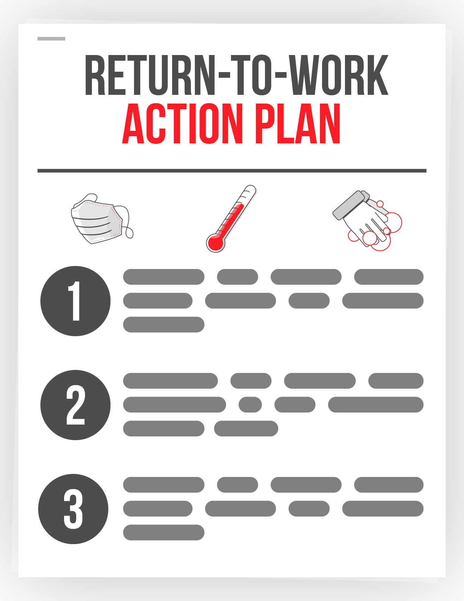
Sample Return to Work Action Plan

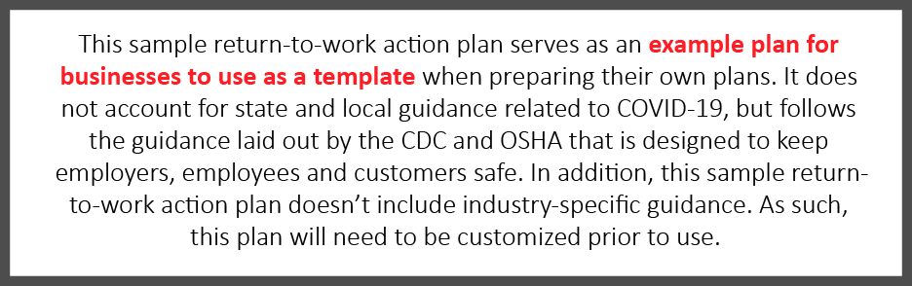

Introduction
At , it is our priority to keep our employees and their families healthy, especially in the midst of the COVID-19 pandemic. As such, we will abide by governmental guidelines when possible as we strive to balance public health concerns with the needs of our business. This return-to-work action plan details how we plan to reopen our business and still keep all of our employees safe to every extent possible. This plan, which pulls from Centers for Disease Control and Prevention (CDC) and Occupational Safety and Health Administration (OSHA) guidance, highlights the responsibilities of managers and employees, and outlines the steps is taking to address COVID-19.
While we will implement various protocols to ensure your safety, it’s up to you and your co-workers to execute on these protocols daily. By releasing this return-to-work action plan, hopes to clearly communicate our plans moving forward, highlight workplace protocols in place to protect your safety and establish a level of comfort for all of our employees as we ask you to return to the office.
We understand that every employee’s situation is different and encourage those with specific risks or concerns to reach out to their manager or HR to discuss alternate arrangements, should they be necessary.

Return-to-Work Timeline
Due to the evolving nature of the COVID-19 pandemic, creating an exact timeline for resuming “normal” operations is not feasible. will continue to monitor applicable state and local guidance and determine next steps for reopening the office.
At this time, we’ve created a tentative phased approach for asking our employees to return to work. To remain consistent with federal guidance, our phased approach to reopening our office mirrors the guidelines included in the White House’s Opening Up America Again Guidelines.

Office Closure

If state and local guidelines mandate it, our office will be closed to employees, vendors and visitors. Employees who are able to work remotely are asked to continue doing so until further notice.

Phase One
Under Phase One, the office may reopen. We will evaluate whether it is possible to open our office and permit a maximum of 10 essential employees to return to work. Social distancing protocols will be put in place and should be followed. However, any other employees who are able to do so should continue to remain home and work remotely. Under Phase One guidance from the government, nonessential travel should be avoided. Business-related travel will not resume under Phase One.

Phase Two
Under Phase Two, the office may reopen to more employees. Government guidance states that in Phase Two, gatherings of up to 50 people are permitted. As such, we will review our situation, consider opening our office and permit a maximum of 50 employees to return to the office. will observe governmental guidelines related to occupancy and capacity given our office’s square footage. Similar to Phase One, employees who are able to work from home should continue to do so. Access to the office will be granted for job roles that are critical to business operations or for employees who are not able to work remotely.
Should we reopen our office in this limited capacity, social distancing protocols will be put in place and workplace modifications may be made to ensure social distancing can be maintained throughout the workday. The following protocols will be put in place to ensure our headcount in the office does not exceed 50 employees and to promote social distancing efforts:
- Staggered and monitored schedules— will implement a tracking system for employees to request and record their attendance in the office. Additionally, rotating schedules will be used until all restrictions are lifted to minimize employee contact.
- Workstation modifications— will modify the office layout to create at least 6 feet of distance between employee workstations, and face-to-face desk layouts will be changed.
- Prohibition of in-person meetings—Until all social distancing requirements are lifted, bans in-person meetings. Instead, employees should conduct virtual meetings. Employees who are in the office should avoid gathering in groups.
In addition to the protocols mentioned above, may implement additional guidance during Phase Two that is designed to promote workplace safety.
Finally, although governmental guidance dictates that nonessential travel may resume under Phase Two, business-related travel will remain banned. A travel approval workflow will be implemented once the majority of states have entered Phase Two of the federal government’s plan. Any employee who travels should follow self-isolation guidelines and not return to work during the isolation to ensure the safety of their peers.

Phase Three
Under Phase Three, the office may reopen to all employees. We will consider reopening the office and implement various protocols to ensure the health and safety of our employees. At this phase, we may also consider resuming business-related travel.

Considerations
It’s important to note that these phases are tentative and are subject to change based on state and local guidance, and the pandemic itself. Should an employee test positive for COVID-19 after the office reopens, our plan may change in an effort to protect our employees. In addition, if cases of COVID-19 spike again in our state or in our local area, we will consider whether to remain open or close.
We recognize that each individual will need to make a personal decision as to when he or she is comfortable returning to the office based on individual circumstances. Please reach out to your supervisor, manager or HR to discuss your personal situation.

Workplace Protocols to Follow When Returning to Work
has implemented various workplace protocols designed to preserve the health and safety of our employees as they return to work. This section further explains these protocols. For additional information, please reach out to your manager or supervisor.

Employee Screening, Exposure and Confirmed Illness Protocols
Keeping employees safe is our priority. To accomplish this task, we have created various procedures for screening employees who return to work, dealing with exposure to COVID-19, responding to a confirmed case of COVID-19 and reporting transparency.

Employee Screening Protocols
The Equal Employment Opportunity Commission permits employers to measure employees’ body temperatures before allowing them to enter the worksite. Any employee screening will be implemented on a nondiscriminatory basis, and all information gleaned should be treated as confidential medical information—specifically, the identity of workers exhibiting a fever or other COVID-19 symptoms should only be shared with members of company management with a true need to know.
employees may be asked to confirm the status of their health as part of working in the office. The company reserves the right to implement a screening protocol for symptoms, such as temperature checks or signed certifications, at any point. Results will be tracked separately from any personnel records and will be kept confidential. This protocol will commonly be implemented upon initial opening of the office and as a response to a confirmed diagnosis. Employees unwilling to complete a screening will be required to work remotely.

COVID-19 Exposure and Confirmed Illness Protocol
Employees who test positive for COVID-19 or believe they have been infected will be instructed to follow the advice of a qualified medical professional and self-isolate. When self-isolating, employees should:
- Stay away from other people in their home as much as possible, staying in a separate room and using a separate bathroom if available.
- Not allow visitors.
- Wear a face mask if they have to be around people.
- Avoid sharing household items, including drinking cups, eating utensils, towels and bedding.
- Clean high-touch surfaces daily.
- Continue monitoring their symptoms, calling their health care provider if their condition worsens.
Notably, employees who are symptomatic or who have tested positive should not return to work until the conditions outlined in the table below are met:
Return-to-Work Considerations
Employee was symptomatic but was not tested for COVID-19. | Employee was tested for COVID-19.
The employee may return to work if:  - They have not had a fever for at least 72 hours and have not used fever-reducing medication during that time.  - Coughs and other symptoms have improved.  - Ten days have passed since they first experienced symptoms. | The employee may return to work if:  - They no longer have a fever.  - Coughs and other symptoms have improved.  - They have received two negative COVID-19 tests in a row.
When an employee tests positive for COVID-19, deep-cleaning procedures will be triggered. Furthermore, employees who have been in close contact with an individual who has tested positive for COVID-19 will be instructed to self-quarantine.

Reporting Transparency Protocol
Any employee who experiences COVID-19 symptoms or has tested positive for COVID-19 must notify HR as soon as practicable. The employee will be asked to assist with contact tracing. This information will be tracked separately from personnel records, and names will not be released. Depending on the circumstances, will notify impacted employees if there is a confirmed case of COVID-19 in the workplace. may elect to close the office for a period up to 72 hours following a confirmed case to allow for natural deactivation of the virus.

Social Distancing Protocol
Employees should follow social distancing best practices while at ’s facilities, including but not limited to workstations, cafeterias, common areas and office spaces. Specifically, employees are asked to:
- Stay 6 feet away from others when working or on breaks. Where a minimum distance cannot be maintained, engineering or administrative controls will be in place.
- Avoid job tasks that require face-to-face work with others when possible.
- Avoid contact with others whenever possible (e.g., handshakes).
- Avoid touching surfaces that may have been touched by others when possible.
- Distance themselves from anyone who appears to be sick.
- Avoid gathering when entering and exiting the facility. Employees should also only enter and exit designated areas.
- Follow any posted signage regarding COVID-19 social distancing practices.
- Disinfect their workspace often.
- Avoid touching their face.
- Avoid nonessential gatherings.
- Stagger lunches to limit the number of individuals in the break room or cafeteria.
- Avoid using common areas.
may extend our social distancing guidelines after the office reopens. Please monitor your email and adhere to any additional guidance as it is provided.

Employee Health and Safety Protocols
The success of our return-to-work action plan relies on how well our employees follow social distancing and health and safety protocols. As such, the following protocols have been implemented to ensure your health and safety. Please bring any concerns regarding the following protocols to a manager or supervisor immediately.

General Employee Health and Hygiene
Practicing good hygiene is essential to prevent the spread of COVID-19. Do your part by practicing good hygiene at work and at home:
- Regularly wash your hands for at least 20 seconds throughout the day with warm water and soap, specifically before eating.
- Cover coughs and sneezes.
- Avoid touching your eyes, nose and mouth.
To help employees remain healthy, has hand sanitizer and disinfecting wipes available throughout the office. We have limited amounts of these supplies and will continue to restock as we are able. It is suggested that employees wash their hands more frequently than normal. Additionally, building management has instructed the office cleaning crew to disinfect key areas such as faucets and door handles on a daily basis.
In addition, employees are strongly encouraged to wear face coverings when in public and when physical distancing of 6 feet or more cannot be guaranteed. Employees will provide their own face coverings in accordance with CDC guidelines. It is recommended that employees wear face coverings when entering and exiting the building and when using common areas such as bathrooms, kitchens and the lobby. will maintain a small inventory of disposable masks and gloves as a backup to employee-provided PPE. Inventory quantities will be regularly tracked and documented but cannot be guaranteed.
Finally, employees who are feeling sick are asked to stay home from the office. Employees who have symptoms of acute respiratory illness, should immediately seek medical attention and follow the guidance of a health care provider. Employees with symptoms are required to work remotely or take PTO. Employees who have been diagnosed with or are aware they’ve been directly exposed to COVID-19 should notify HR.

Employee Mental Health Considerations
understands that the COVID-19 pandemic has increased stress levels of employees across the country. We want to prioritize our employees’ mental health during these uncertain times. As such, we have made every effort to ensure that the workplace is safe for employees to return to work and are ready to discuss personal situations. Managers and supervisors are aware of mental health considerations during this transition. Employees with concerns regarding their mental health should request additional resources from their manager or supervisor.

Cleaning and Disinfecting Protocol
Employees should do their part to help keep the office as clean as possible by cleaning and disinfecting their workstations and surfaces they commonly use. Employees should also avoid using others’ workstations, tools and equipment. Additionally, whenever an employee uses a common piece of equipment (e.g., printer or fax machine), it should be wiped down prior to and following use. Proper cleaning and disinfecting supplies will be provided by . Employees should wash their hands with warm water and soap for at least 20 seconds after cleaning or sanitizing a surface.
has requested that building management facilitates cleaning of common areas and other frequently touched surfaces throughout the day. The frequency of this cleaning may change depending on the situation.

Office Procedures
In addition to the guidance outlined above, has implemented the following workplace procedures to be followed until social distancing guidelines are lifted:
- Deliveries— will set up contactless drop zones for all deliveries, including mail and packages. An assigned contact or contacts will process mail and packages at least three times per week, utilizing gloves. Employees ordering food delivery service will need to instruct drivers to utilize drop-off zones for contactless delivery.
- Visitors—Until further notice, all nonessential visitors are prohibited and any interviews should be conducted virtually. For business-critical visits (e.g., material deliveries), will take steps to safeguard employees and visitors by:
  - Requiring visitors to go directly to their assigned work area without unnecessarily interacting with employees
  - Requiring visitors to practice social distancing and good hygiene while on-site
- Vending and catering services—To ensure the health of employees, will observe governmental guidelines and restrictions related to self-serve vending stations. In the absence of vending, employees will be responsible for bringing their own food and beverage, preferably in a temperature-controlled bag. It is recommended that all dishware be taken home nightly for cleaning in a dishwasher. The company will avoid catering events that allow for cross-contamination.
may add to this list of workplace procedures as employees return to work. Employees should monitor workplace communications to ensure they’re up to date on all health and safety communications.

Conclusion
looks forward to the future of our employees returning to work. The COVID-19 pandemic has created uncertain times and resulted in unprecedented workplace changes. As communicated throughout this return-to-work action plan, we are prioritizing the health of our employees every step of the way as we consider reopening our business’s doors.
We will execute on our plan cautiously, following applicable state and local guidance as much as possible. We also understand that each employee’s needs and situations will be different as our doors begin to reopen. Employees should discuss any concerns they have about returning to work as it relates to their personal health or situation with their manager or supervisor.
Finally, we ask that employees are patient and understanding of the fact that the COVID-19 pandemic may require our return-to-work plans to change. Employees will be given as much notice as possible in the event of an unforeseen setback or office closure.
Employees should direct questions regarding the content of this action plan to their supervisor. Furthermore, while the strategies highlighted in this document can protect workers from COVID-19, it’s important to follow CDC guidance at all times. For more information, click here.

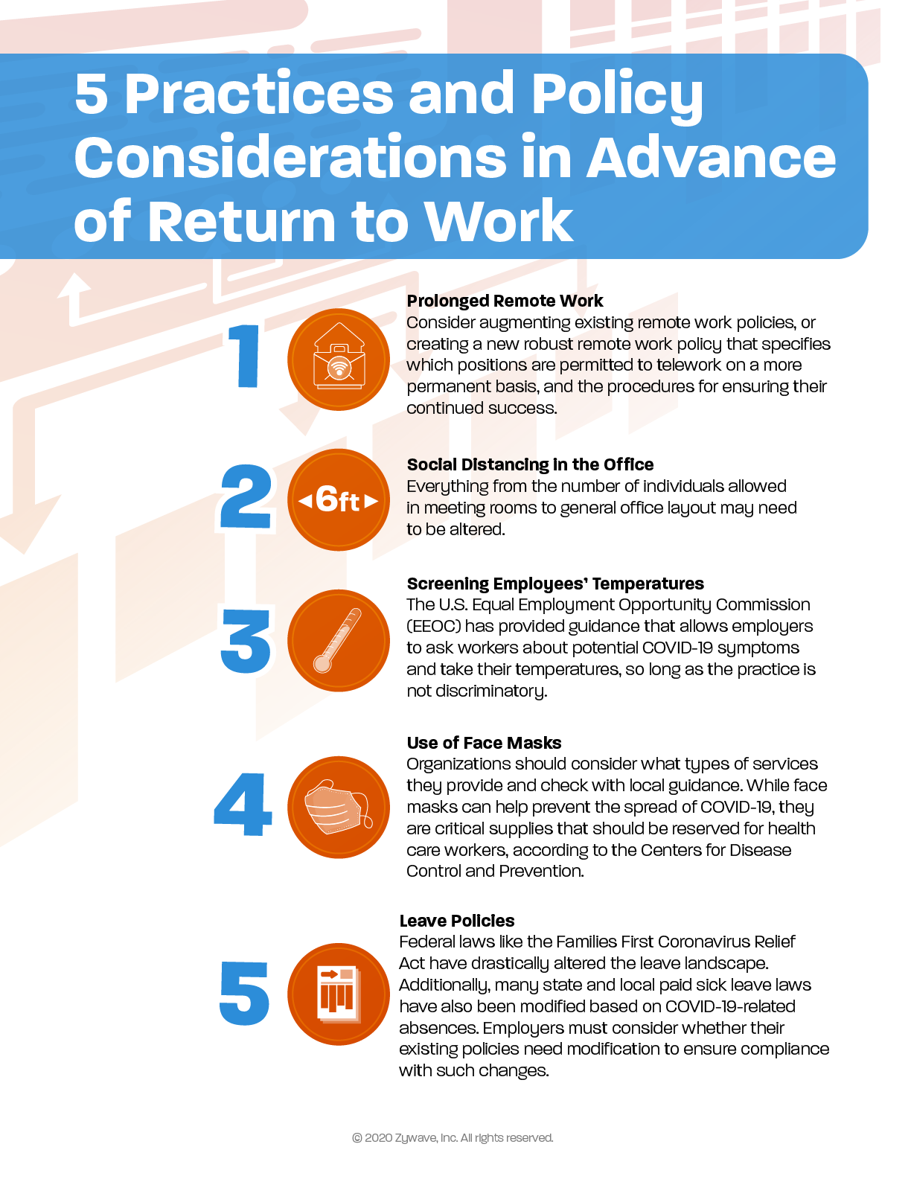
5 Practice and Policy Considerations in Advance of Return to Work – Poster
Words

Post-coronavirus Workplace Preparedness Checklist
Presented by Lipscomb & Pitts Insurance, LLC

The coronavirus disease (COVID-19) pandemic has changed many aspects of the current workplace, and hygiene and cleanliness are key topics when creating post-coronavirus workplace plans. Based on guidance from the Centers for Disease Control and Prevention (CDC), there are actions employers can consider. By taking workplace preparedness steps such as updating office layouts, encouraging new behaviors and evaluating existing policies, employers can help prevent the spread of COVID-19 and protect the health and safety of employees. To get started, employers can review topics on this checklist.

Employee Behaviors | YES | NO | N/A
Are employees practicing social distancing, maintaining a distance of 6 feet or more from each other? | ☐ | ☐ | ☐
Are employees washing their hands regularly for 20 seconds with soap and water? | ☐ | ☐ | ☐
Are employees practicing social distancing in meetings? | ☐ | ☐ | ☐
Are employees avoiding the use of multi-touch devices, such as shared computers in meeting rooms? | ☐ | ☐ | ☐

Personal Protective Equipment | YES | NO | N/A
Are employees expected to wear face coverings or masks in the workplace? | ☐ | ☐ | ☐
Are face coverings or masks provided to employees? | ☐ | ☐ | ☐
If face coverings or masks are not provided to employees, is a reimbursement program in place for any costs of face coverings, masks or necessary materials? | ☐ | ☐ | ☐
Are gloves provided to employees? | ☐ | ☐ | ☐

Employee Communications | YES | NO | N/A
Are employees trained on what COVID-19 related symptoms to look for? | ☐ | ☐ | ☐
Have employees received communications regarding COVID-19 workplace best practices? | ☐ | ☐ | ☐
If using face coverings or masks, have employees been trained on proper procedures? | ☐ | ☐ | ☐

Cleaning | YES | NO | N/A
Are routine cleanings conducted frequently? | ☐ | ☐ | ☐
Do cleaning routines use soap and water, and disinfectants listed by the Environmental Protection Agency (EPA) to use against SARS-CoV-2, the virus that causes COVID-19? | ☐ | ☐ | ☐
Are cleaning supplies stocked, including EPA-recommended disinfectants? | ☐ | ☐ | ☐
Are all multi-touch surfaces such as doorknobs part of cleaning routines? | ☐ | ☐ | ☐
Are hand sanitizer and sanitizer wipes provided to employees? | ☐ | ☐ | ☐
If using face coverings or masks, does your organization have a cleaning procedure in place? | ☐ | ☐ | ☐

Workplace Facilities, Equipment and Layout | YES | NO | N/A
Do employees have workstations 6 feet or more apart? | ☐ | ☐ | ☐
Are walls or barriers set up between employee workstations? | ☐ | ☐ | ☐
Has a walk-traffic flow that discourages congestion been established? | ☐ | ☐ | ☐
Do facilities have high-functioning air filters? | ☐ | ☐ | ☐
Do facilities have automatic doors? | ☐ | ☐ | ☐
Do bathrooms have no-touch sinks and soap dispensers? | ☐ | ☐ | ☐
Do bathrooms have no-touch paper towel dispensers? | ☐ | ☐ | ☐

Policies and Preparedness | YES | NO | N/A
Is a hand-washing policy in place? | ☐ | ☐ | ☐
Has a social distancing meeting policy been established? | ☐ | ☐ | ☐
Is a policy in place to protect employees in COVID-19 high-risk categories? | ☐ | ☐ | ☐
Does your organization have a prepared response for employees who have COVID-19-related symptoms? | ☐ | ☐ | ☐
Does your organization have a planned response in place in the event of an employee testing positive for COVID-19? | ☐ | ☐ | ☐
Use this checklist as a guide when planning your post-coronavirus workplace preparedness plan. For any checklist items you select “NO,” consider whether any updates could help protect the health and safety of your employees. For assistance with COVID-19-related topics, contact Lipscomb & Pitts Insurance, LLC.

This checklist is merely a guideline. It is neither meant to be exhaustive nor meant to be construed as legal advice. It does not address all potential compliance issues with federal, state or local standards. Consult your licensed representative at Lipscomb & Pitts Insurance, LLC or legal counsel to address possible compliance requirements. © 2020 Zywave, Inc. All rights reserved.

Responding to a Positive COVID-19 Test Checklist
Presented by Lipscomb & Pitts Insurance, LLC
The coronavirus (COVID-19) pandemic has challenged employers to plan for how they would respond to a positive test in their workplace. Employers are responsible for handling the situation swiftly to protect the health of other employees while preserving the affected employee’s confidentiality. In addition to notifying the company and its customers, employers must also disinfect the office and evaluate next steps. If you’re in this situation, you may be wondering what you need to do. The Centers for Disease Control and Prevention (CDC) provides guidelines for how employers can respond, and this checklist provides an outline of steps for employers to consider.

Employer Preparedness Plans | YES | NO | N/A
Does your organization have COVID-19 testing practices in place that comply with all applicable federal and local guidance? | ☐ | ☐ | ☐
Does your organization have a planned response in place in the event of an employee testing positive for COVID-19? | ☐ | ☐ | ☐
If yes, has a planned response been communicated to employees? | ☐ | ☐ | ☐

Addressing Employee Who Tested Positive
Calmly and empathetically address the employee to discuss next steps and assistance. | ☐
Ensure the employee that their identity will remain confidential. | ☐
Question the employee about with whom they have been in contact within the last 14 days. | ☐
Determine if the employee has been in the workplace within the last seven days. | ☐
Ensure the employee goes into isolation, and help them coordinate taking leave or paid time off until they’ve recovered. | ☐
Refer the employee to local health resources. | ☐

Communications
Notify any co-workers or customers with whom the ill employee had been in contact. | ☐
Make determinations on any employees who should begin self-isolation for 14 days. Communicate steps for self-isolation, including taking leave, paid time off or remote work arrangements. | ☐
Notify the rest of the company by email or letter that an employee has tested positive for COVID-19. Keep the employee’s identity confidential. | ☐
Notify employees on next steps, including details for a partial or full closing of the workplace for disinfecting. | ☐
If planning on having any or all employees work from home or closing the office, disclose this information in the communication. | ☐

Close Down the Workplace
Determine whether the workplace will be partially or fully closing for disinfecting. | ☐
If feasible, allow eligible employees to work from home during this time. | ☐
Ensure all temporary closing information is communicated to employees, including whom this affects, remote work expectations, paid time off, leave and expected timelines for reopening the workplace. | ☐
Review provisions included in the newly instituted federal leave act, the Families First Coronavirus Response Act (FFCRA), should you need to close the office or if employees opt to take leave due to COVID-19. Certain employers are required to provide employees with expanded family and medical leave for specified reasons related to COVID-19 through Dec. 31, 2020. | ☐
Create plans for only cleaning staff to be in infected areas for 72 hours during the disinfecting period. | ☐

Preparing for Disinfecting
If the employee has been in the workplace within the last seven days, begin preparations for disinfecting the workplace. | ☐
Ensure necessary cleaning supplies are stocked, including soap and disinfectants listed by the Environmental Protection Agency (EPA) to use against SARS-CoV-2, the virus that causes COVID-19. | ☐
Ensure personal protective equipment is stocked for cleaning teams, including gloves, gowns and face coverings. | ☐
Evacuate planned areas for disinfecting for at least 72 hours. | ☐

Disinfecting the Workplace
Close off all areas visited by the person, open windows and use ventilating fans with airflow. After opening up the airflow, wait 24 hours before beginning cleaning. | ☐
After 24 hours, cleaning staff should begin disinfecting all areas and equipment used by the person. | ☐
Ensure cleaning staff is using personal protective equipment, including gloves, gowns and face coverings. | ☐
Begin by cleaning all hard surfaces with soap and water. | ☐
Apply a disinfectant to all surfaces. The EPA lists appropriate disinfectants for use against SARS-CoV-2, the virus that causes COVID-19. | ☐
Clean soft surfaces such as carpeted floor, rugs and drapes. For soft surfaces, best cleaning practices are similar to those of hard surfaces. However, you can clean by laundering if possible. If not an option, continue to clean with a disinfectant. | ☐
Clean electronic devices, according to manufacturers’ instructions, or with alcohol-based cleaning solutions with at least 70% alcohol. | ☐
Clean soft laundry items, such as towels, linens and work-related clothing using manufacturers’ instructions, using the warmest possible water setting. | ☐
When employees return after 72 hours, resume routine cleaning routines. | ☐

Use this checklist as a guide when planning how to respond to an employee testing positive for COVID-19. For any items you are unable to check, consider if any updates to your organization’s response could help protect the health and safety of employees and guests. By preparing in advance, employers can swiftly respond to the employee, effectively notify the rest of their organization and make plans for moving forward. Lipscomb & Pitts Insurance, LLC is here to help during these uncertain times. Contact us today for additional COVID-19 resources and guidance for how your company can respond to it.

This checklist is merely a guideline. It is neither meant to be exhaustive nor meant to be construed as legal advice. It does not address all potential compliance issues with federal, state or local standards. Consult your licensed representative at Lipscomb & Pitts Insurance, LLC or legal counsel to address possible compliance requirements. © 2020 Zywave, Inc. All rights reserved.

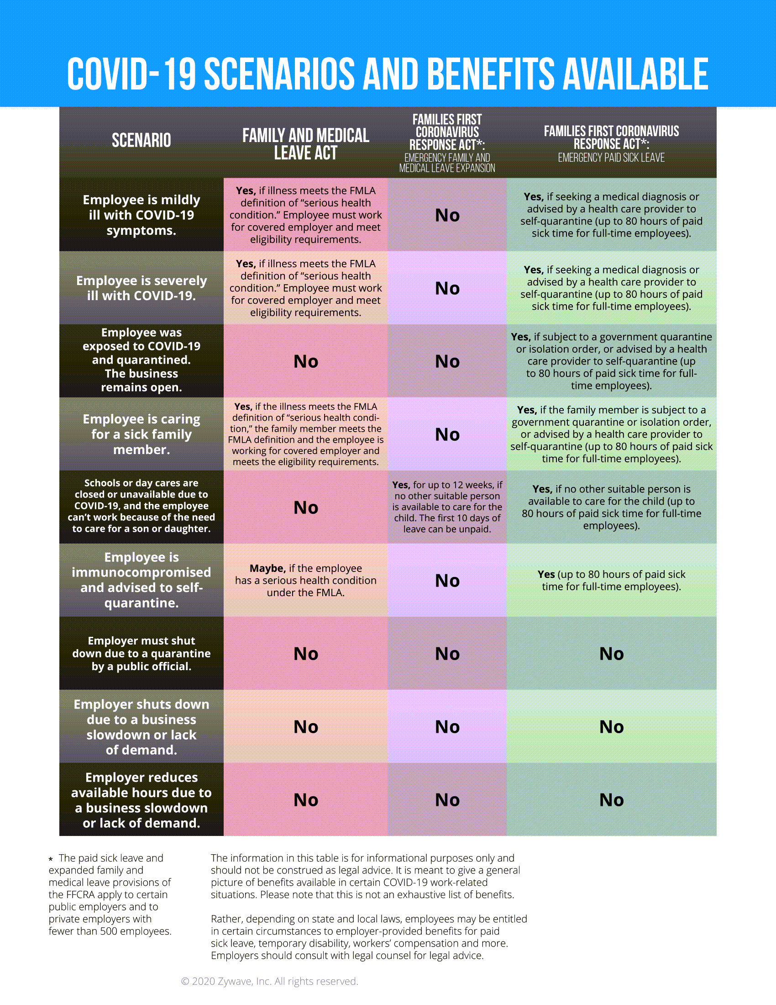
COVID-19 Scenarios and Benefits Available Chart

Remote Work Policy

This SAMPLE policy is of general interest and is not intended to apply to specific circumstances. Make sure to consult legal counsel to customize this agreement prior to implementation.
Purpose
This policy establishes the guidelines will use to select and manage those employees approved to work remotely.
Scope
This policy applies to all employees authorized to work remotely as a primary job function. This policy also includes those employees who are temporarily allowed by their managers to work from home or other locations due to extenuating circumstances, such as cases of public emergency and/or in compliance with public health guidance for contagious diseases.
POLICY GUIDELINES
Definitions
Telework refers to an arrangement where an employee works from home or from another location away from the usual workplace. Depending on the details of the arrangement, telework constitutes either a portion of the employee’s work time or all of it. Typically, the telework arrangement is initiated by an employee’s request (although it can be a condition of employment).
Criteria for Selection
always strives to provide equal opportunities to all employees when it comes to working situations. However, remote work is not conducive to every employee and position. Keeping this in mind, will review all reasonable employee requests to work remotely using the following criteria:
- Is the employee a good candidate for telecommuting? Criteria include:
  - Dependability
  - Flexibility
  - Proven performance
  - No record of disciplinary action
  - Comprehensive knowledge of their position
- Can the duties of the position be successfully fulfilled through telecommuting? Criteria include:
  - Measurable work activities
  - Little need for face-to-face interaction with co-workers
  - Clearly established goals and objectives
  - Duties that can be performed alone
  - Equipment needs that are limited and can be easily stored at the off-site location
Note: The management of reserves the right to deny or revoke remote work privileges at their own discretion.
Responsibilities
Position requirements and responsibilities will not change due to telecommuting. Workers face the same expectations in relation to professionalism, work output and customer service, regardless of where the work is being performed. The amount of time an employee is expected to work in a given week will not change, although the exact scheduling of allotted hours will be left up to the discretion of their direct supervisor(s). If an employee’s physical presence is required at ’s primary work location, he or she may be expected to report once given adequate notice.
Additionally, employees are expected to abide by the following general rules
- Be transparent about your availability and keep your calendar and availability status up to date, indicating when you are online or offline.
- Maintain strong communication by conducting regular check-ins with your manager and co-workers.
- Utilize your webcam and phone instead of email as often as possible.
- Request PTO when you intend to be away from your work.
- Set up a dedicated workspace that allows you the most focus as possible.
- Prepare a child care strategy if needed. Don’t work and parent at the same time.
- Be patient and understanding with co-workers who don’t have ideal at home working conditions.
Contact With Primary Location
Employees approved for telecommuting are responsible for maintaining regular contact with their supervisor(s). The supervisor(s) will act as the employee’s primary contact at . Both the employee and his or her supervisor(s) are expected to work together to keep each other informed of any developments that occur during the workday.
Employees must have approval from their supervisor(s) to:
- Alter their defined work schedules.
- Move company equipment to a new location.
- Transfer primary off-site operations to a new location.
Expenses
Working primarily at home could result in expenses not directly addressed by this policy. If such expenses are necessary for their official duties as prescribed, will reimburse the employees. However, since reimbursement is subject to management approval and is not guaranteed, potential expenditures should always be approved prior to the transaction being made.
Equipment
On a case-by-case basis, will determine, with information supplied by the employee and the supervisor, the appropriate equipment needs (including hardware, software, modems, phone and data lines, and other office equipment) for each telecommuting arrangement. The human resource and IT departments will serve as resources in this matter. Equipment supplied by the organization will be maintained by the organization. Equipment supplied by the employee, if deemed appropriate by the organization, will be maintained by the employee.
It must be kept in mind that:
- All equipment purchased by remains the property of . All equipment—including laptop and corresponding portable power supply, and voice devices such as a headset—is to be returned in a timely fashion should the employee cease telecommuting operations for any reason.
- Hardware is only to be modified or serviced by parties approved by .
- Software provided by is to be used only for its intended purpose and should not be duplicated without consent.
- Any equipment provided by for off-site use is intended for legitimate business use only.
- All hardware and software should be secured against unauthorized access.
Employee Acknowledgement
I have read and agree to the terms of this remote work policy, and I agree to the duties, obligations, responsibilities and conditions outlined herein.

Employee Signature: __________________________________ Date: _______________

Sample Return-to-Work Employee Communications Email
Dear [insert employee name],
We’ve been looking forward to the day we’d be able to reopen our doors to our employees, and that day is coming soon. is excited to announce that our business will officially reopen [insert date]. [Insert details about your company’s reopening schedule. Sample text: We will be open for business Monday-Friday 9 a.m. to 6:30 p.m., with employees working staggered schedules for safety.]
The decision to reopen our business was not taken lightly—we carefully reviewed federal, state and local reopening guidelines and considerations. After much discussion, we decided that we could reopen our doors and created a plan that will help us do so while preserving your health and safety.
At , it is our priority to keep our employees and their families healthy, especially in the midst of the COVID-19 pandemic. As such, we will abide by governmental guidelines when possible as we strive to balance public health concerns with the needs of our business. Some notable workplace changes include the following:
[This list below features sample text regarding workplace updates. Customize prior to distributing to employees.]
- Modified office layout—We’ve updated workstations to ensure that they’re suitable for social distancing protocols, closed our communal spaces and set up no-touch doors.
- Increased office cleaning—Cleaning crews will clean the office twice daily, focusing on sanitizing and disinfecting high-touch surfaces.
- Updated employee protocols—We’ve implemented various employee health and safety protocols that focus on social distancing, health screening and general hygiene reminders to keep our employees safe and healthy while returning to work.
is excited to welcome you back to work, and we’re confident that, by working together, we can establish a safe, new normal that works for our business and employees. We feel that the plans and procedures put in place will help make your transition back to the office a success, but we want to know how our plans can be improved. Please reach out to your manager or HR with your suggestions—we’d love to hear them!
Best regards,

Remote Work Agreement Form

This SAMPLE agreement is of general interest and is not intended to apply to specific circumstances. Make sure to consult legal counsel to customize this agreement prior to implementation.
Purpose and Scope
This document establishes the terms and conditions of the agreement between [insert employee name] and to conduct remote work. reserves the right to deny or revoke remote work privileges at their own discretion.
Employee Information:
Name: __________________________________________________________
Job title: ________________________________________________________
Department: _____________________________________________________
Remote work start date: _________________ End date: __________________
Temporary work location: ___________________________________________
Employee schedule: _______________________________________________
Definitions
Remote work refers to an arrangement where the employee works from home or from another location away from the usual workplace. Depending on the details of the arrangement, remote work constitutes either a portion of the employee’s work time or all of it.
Responsibilities
Position requirements and responsibilities will not change due to remote work. Employees face the same expectations in relation to professionalism, work output and customer service, regardless of where the work is being performed. The amount of time an employee is expected to work in a given week will not change, although the exact scheduling of allotted hours will be left up to the discretion of their direct supervisor(s). If an employee’s physical presence is required at ’s primary work location, he or she may be expected to report once given adequate notice.
Additionally, the employee agrees to abide by the following general rules:
- Be transparent about your availability and keep your calendar and availability status up to date, indicating when you are online or offline.
- Maintain strong communication by conducting regular check-ins with your manager and co-workers.
- Utilize your webcam and phone instead of email as often as possible.
- Request PTO when you intend to be away from your work.
- Set up a dedicated workspace that allows you the most focus as possible, and that is ergonomically sound and free of hazards.
- Understand that remote work is not a substitute for dependent care. Prepare a child care strategy if needed. Don’t work and parent at the same time.
- Be patient and understanding with co-workers who don’t have ideal at-home working conditions.
Contact With Primary Location
The employee agrees to maintain regular contact with their supervisor(s). The supervisor(s) will act as the employee’s primary contact at . Both the employee and his or her supervisor(s) are expected to work together to keep each other informed of any developments that occur during the workday.
The employee must receive approval from their supervisor(s) to:
- Alter their defined work schedules.
- Move company equipment to a new location.
- Transfer primary off-site operations to a new location.
Equipment
The employee agrees that, on a case-by-case basis, may determine, with information supplied by the employee and the supervisor, the appropriate equipment needs (including hardware, software, modems, phone and data lines, and other office equipment) for each remote work arrangement. The human resource and IT departments will serve as resources in this matter. Equipment supplied by the organization will be maintained by the organization. Equipment supplied by the employee, if deemed appropriate by the organization, will be maintained by the employee.
Additionally, the employee agrees to abide by the following general rules:
- All equipment purchased by remains the property of .
- Hardware is only to be modified or serviced by parties approved by .
- The employee must report to any damage or modification to company-provided equipment as soon as possible.
- Software provided by is to be used only for its intended purpose and should not be duplicated without consent.
- Any equipment provided by for off-site use is intended for legitimate business use only.
- All hardware and software should be secured against unauthorized access.
- All equipment—including laptop and corresponding portable power supply, and voice devices such as a headset—is to be returned in a timely fashion should the employee cease remote work operations for any reason.

SIGNATURES
I have read, understand and agree to comply with all provisions of the Remote Work Agreement. I understand that any violation of the terms of this agreement may result in disciplinary action up to and including termination. My signature serves as proof that I agree to the terms and conditions of this agreement.
EMPLOYEE NAME: | SIGNATURE: | DATE:
MANAGER NAME: | SIGNATURE: | DATE:

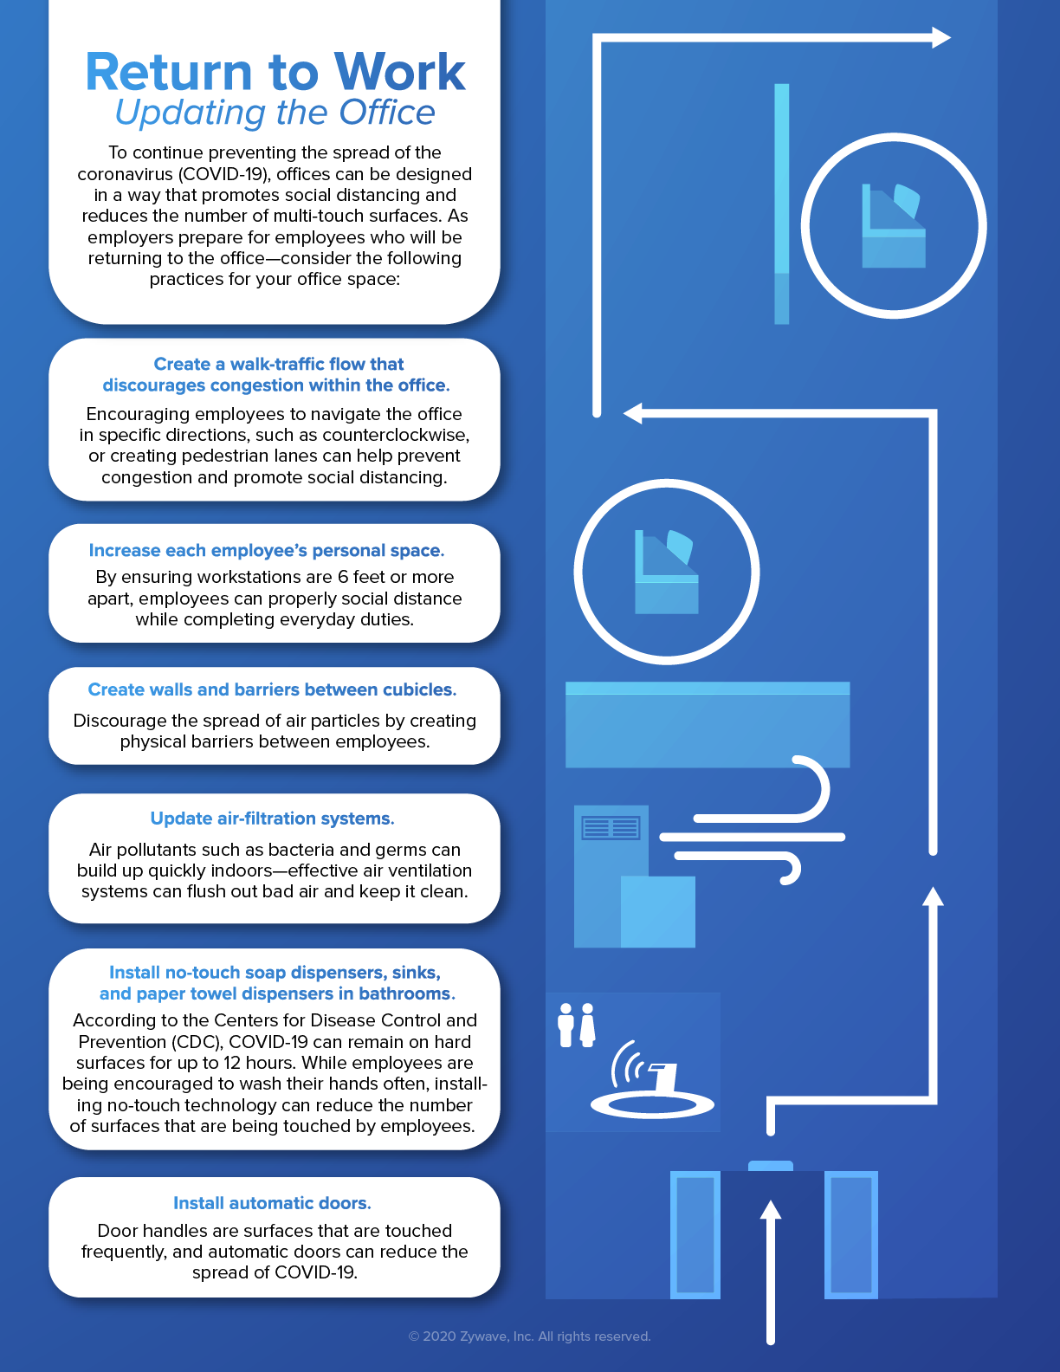
Updating the Office Poster

