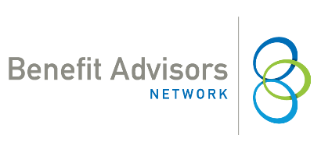
March 23, 2020 | LEGAL ALERT

Collecting Premiums During Employee’s Leave of Absence

When an employee takes an unpaid leave of absence, the question arises on how an employer should collect benefit premium payments to continue benefits during that time. The only regulatory guidance on this comes from the original Family and Medical Leave Act (FMLA) regulations.
Following those, employers have three choices, they can utilize just one method, two methods or all three:

- Pay in advance. Employers can collect a lump sum payment for missed payroll deductions in advance of the leave of absence. Employees should consult with their personal tax advisor on any credits or deductions they might receive for paying premiums post-tax.
- Pay as you go. Employees can remit payment post-tax, with payment deadlines coinciding with pay periods. Employers should set firm guidance on where to remit payment, when it is due, and warn employees that missed payments will subject the employee to plan termination retroactive to the due date of the payment; which could expose the employee to claims if they seek healthcare services during that time.
- Pay upon return. Employers can allow employees to pay premiums pre or post-tax upon return. It is highly encouraged to give employees a certain amount of pay periods to pay back each missed premium payment. All employees should be provided the same amount of time to pay back missed premiums. For example, employees could be provided 2 pay periods to pay back one missed premium payment. Employees who do not return to work and do not pay back their premiums can either have coverage terminated retroactively to the last date paid, or the employer can treat the missed payment as a debt. Counsel should be consulted on how to handle this debt. Employers should clearly communicate the ramifications of not returning to work on the employee’s coverage.

The information provided in this alert is not, is not intended to be, and shall not be construed to be, either the provision of legal advice or an offer to provide legal services, nor does it necessarily reflect the opinions of the agency, our lawyers or our clients. This is not legal advice. No client-lawyer relationship between you and our lawyers is or may be created by your use of this information. Rather, the content is intended as a general overview of the subject matter covered. Those reading this alert are encouraged to seek direct counsel on legal questions.

This email is a service to our clients and friends. It is designed only to give general information on the developments actually covered. It is not intended to be a comprehensive summary of recent developments in the law, treat exhaustively the subjects covered, provide legal advice, or render a legal opinion.

Benefit Advisors Network and its members are not attorneys and are not responsible for any legal advice. To fully understand how this or any legal or compliance information affects your unique situation, you should check with a qualified attorney.
© Copyright 2020 Benefit Advisors Network. All rights reserved.

