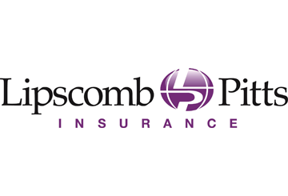
Stimulus Bill Includes Ban on Surprise Medical Bills
Important Dates
Dec. 27, 2020
The Consolidated Appropriations Act, 2021 was signed into law.
July 1, 2021
Implementing regulations required to be issued.
Jan. 1, 2022
The provisions of the No Surprises Act apply to plan or policy years beginning on or after Jan. 1, 2022.
On Dec. 27, 2020, President Trump signed the Consolidated Appropriations Act, 2021 into law. The Act includes a $900 billion coronavirus relief package that provides funding for unemployment benefits, direct economic payments to individuals, vaccine distribution and rental assistance. It also includes the No Surprises Act, a ban on surprise medical bills, which takes effect beginning in 2022.
Surprise Medical Bills
Surprise medical bills occur when patients unexpectedly receive care from out-of-network health care providers. For example, a patient may go to an in-network hospital for treatment, such as surgery or emergency care, but an out-of-network doctor may be involved in the patient’s care.
Patients often cannot determine the network status of these providers during treatment in order to avoid the additional charges. In many cases, the patient is not involved in the choice of provider at all.
No Surprises Act
The Act applies to surprise bills from doctors, hospitals and air ambulances. It will prohibit these providers from billing patients who have health coverage for unpaid balances. Rather, providers will have to work with the group health plan or health insurance issuer to determine the appropriate amount to be paid by the plan or issuer, under the methodology provided in the Act.
The Depts. of Health and Human Services, Labor and the Treasury will work together to issue regulations regarding this methodology and other requirements of the Act.
Lipscomb & Pitts Insurance, LLC will continue to keep you updated as information becomes available on the details of the law.
Providers will have to agree with health plans and issuers on a payment amount instead of billing patients for unpaid balances.
Provided to you by Lipscomb & Pitts Insurance, LLC

